Pastoral leaflet for families who seek the burial of a loved one in a churchyard
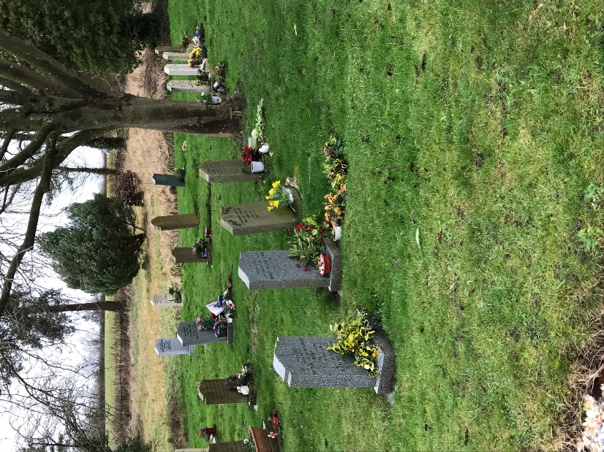
The death of a loved one is one of the most traumatic things we will ever face in life. It is a time when emotions are at the fore and when making decisions can be tough. We in the Diocese of Coventry recognise this and want to do all we can to help you make good decisions for you and your loved ones at this difficult time.

One of those decisions, unless specified in a will, will be around the final resting place of a loved one. Many people will choose to bury their loved one in a Church of England churchyard if the deceased is eligible, but you need to be aware that churchyards are governed by law and it is often the case that certain types of memorial stones and other ornaments, artificial flowers etc which are permitted in a municipal cemetery are not permitted in a churchyard. We therefore want to make you aware of that at an early stage after the death of your loved one so that you can be informed before a burial takes place.

The Churchyard Regulations for the Diocese of Coventry can be found at www.dioceseofcoventry.org/churchyards/Memorials
We would like to encourage you to read these and to have a discussion with your local vicar so that you are aware of what is possible within a churchyard before making a decision about burial and memorials.

A Churchyard memorial is very significant. It is important, therefore, to make sure that every memorial erected in a churchyard meets a family’s needs. Yet, at the same time, we have to think of the needs of:

- Other families, who will have loved ones buried nearby;
- The local church, on whom the upkeep of the churchyard normally falls;
- Generations to come, who will be looking at the memorial long after today’s bereaved people are themselves dead.

The burial of a relative does not automatically give the right to have a memorial. Permission must, therefore, always be sought for any memorial. This can only be given by the Chancellor of the Diocese. (He is the senior legal officer of the Church of England locally and it is his responsibility to do what he believes is best for the churchyard both now and for future generations.)

However, there are some memorials for which the Chancellor has authorised the local vicar to give permission. At pages 5 to 10 of the Regulations, there is a summary of the types of memorials which a vicar is authorised to permit. It is a summary and your vicar will be able to advise you whether a particular kind of memorial is one which he or she is or is not authorised to permit. For other memorials, a Faculty (a legal permission) will need to be obtained from the Chancellor and he will normally need to be given a good reason as to why he should give permission for this particular type of memorial.

It is important to note that the existence in a churchyard of a similar memorial to the one desired will not usually be a reason for permission to be granted. For example, the existence of kerbs around a memorial is not a reason for permission to be given for new kerbs to be installed – once immediate relatives of the deceased leave the area or themselves die, the burden of tending the grave falls directly on the local church, which will find the task more straightforward if there are no kerbs.

How do you go about erecting a memorial?

- Please do not enter into any agreement with a memorial mason for supplying a memorial until you have received written permission from the local vicar, or a faculty has been obtained from the Diocesan Chancellor.
- It is a good idea, at an early stage, before talking to a memorial mason about design and material to consult your local vicar (this will help to avoid difficulties later in the process) and to obtain the appropriate form. ]
- Then you need to decide whether to create an individually designed memorial, or to approach a firm of memorial masons to produce one of a more standard design from a catalogue.
- Once the proposed memorial is agreed in principle, and provided it falls within the vicar’s delegated authority, you need to make an application to the local vicar on the form for this purpose and permission can be given quickly.
- If the proposed memorial falls outside a vicar’s delegated authority, you will have to apply to the Chancellor for a faculty (permission) for which a fee is payable. You will need to complete a faculty application form, obtainable from the Diocesan Registrar, to whom it should also be returned.

We realise that this a very difficult and stressful time for you and we want to do all we can to help you with this process.

Your local vicar is NAME

If there is a vacancy at the Church, your Area Dean may be able to help. This is NAME

Diocesan Contacts
Will Jones, Secretary to the Diocesan Advisory Committee:
024 7652 1327

Michelle McBrierty, Diocesan Registry Clerk: 024 7622 7331

Ven. Sue Field, Archdeacon Pastor: 024 7652 1337

