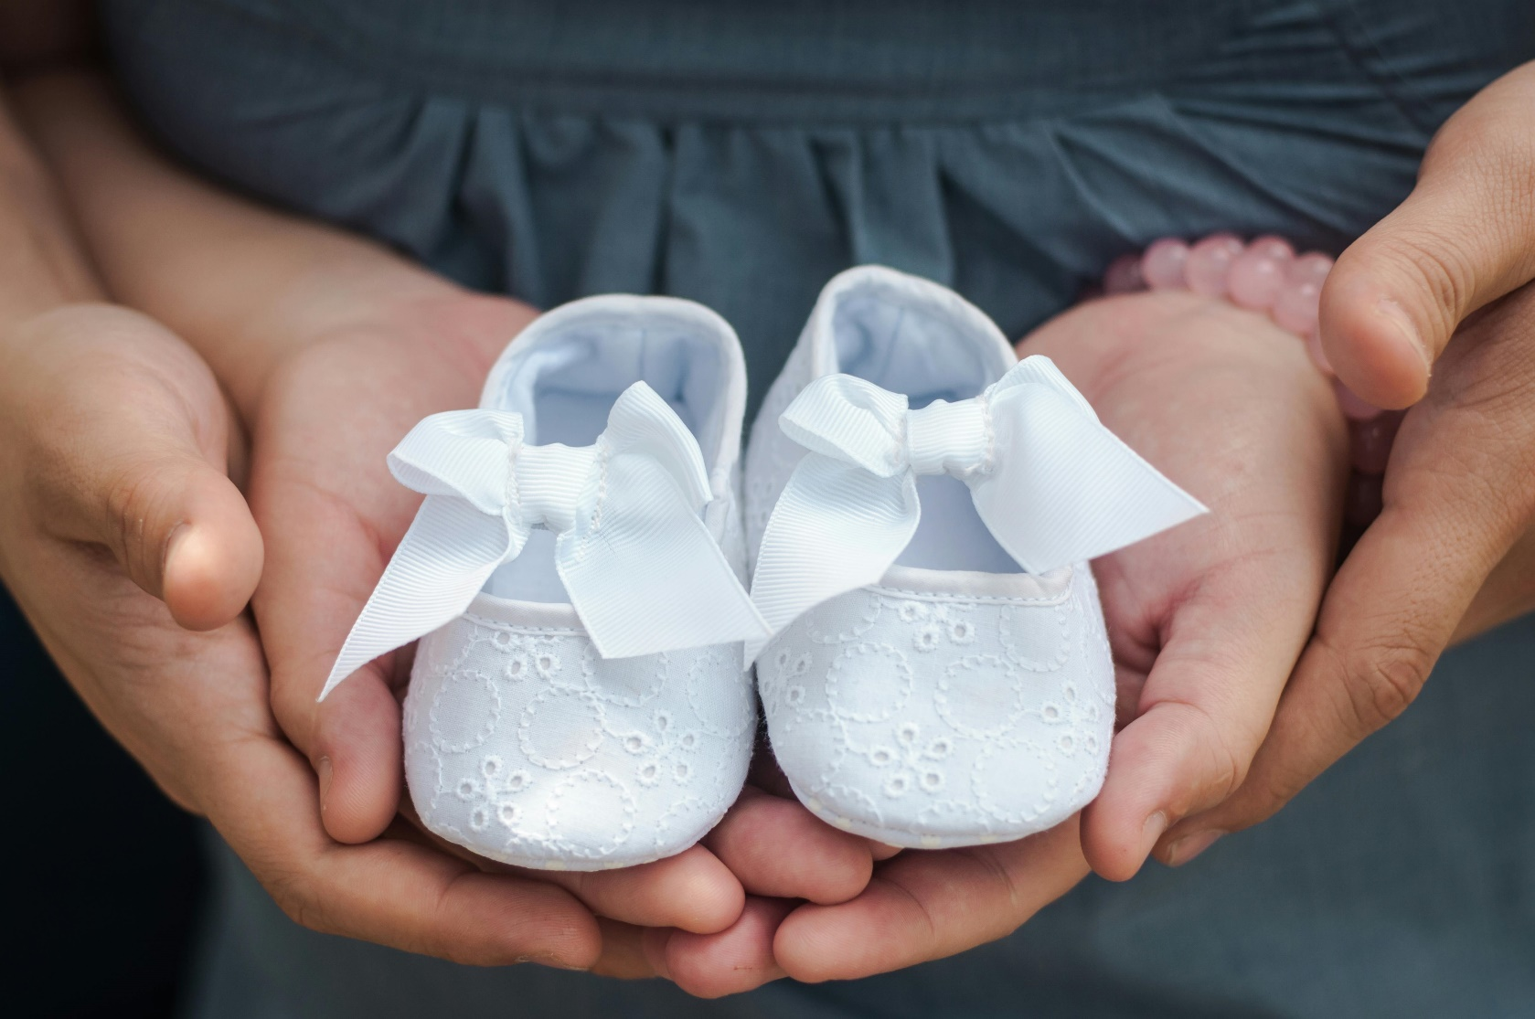

Parish Name

Maternity Pack

Contents
Pre-maternity leave information 3
Pregnancy and Maternity Policies 3
Risk Assessments 3
Ante-natal Appointments 3
Documentation and Dates of leave 3
Payments 4
Pension and AVC’s 4
Annual Leave Accrual 4
Clothing 5
Confirming the birth of the baby 5
Health and Wellbeing 5
Free dental care and NHS prescriptions 5
Health advice 5
Practical Advice and Support 5
Freebies 5
Packing your hospital bag 6
Registering the birth of your child 6
How to apply for child benefit 6
During Maternity Leave 7
Keeping in Touch (KIT) days 7
Postnatal depression 7
At the end of Maternity leave 7
Return to work process 7
What job you will return to 8
Breastfeeding and expressing milk 8
Flexible working 8
Time off for dependants 9
Parental leave 9
Carer’s Leave 9
Childcare 9

Pre-maternity leave information
Congratulations on your pregnancy. We wish you and your family all of God’s blessings through this special time!
Detailed below is information on things which you may find helpful during your pregnancy and maternity leave.

Pregnancy and Maternity Policies
In summary, you are entitled to 52 weeks maternity leave, regardless of how long you have worked for us.
Enclosed with this pack is the ‘Pregnancy and Maternity Policy’ which goes into more detail about your pregnancy and maternity and will support you in making decisions about how and when you take your leave. The “Shared Parental Leave” Policy has also been enclosed should you decide that you and your partner will share the maternity leave period. There are other policies attached which we will go into more detail further down this pack.

Risk Assessments
When you first let your line manager know that you are pregnant, they will arrange for you to do an initial risk assessment. This is to check that your job is not putting you at risk of any pregnancy related complications. As an outcome of the risk assessment, your line manager may amend your duties slightly to accommodate your pregnancy. In rare cases, it may be that your current role cannot be completed as normal whilst you are pregnant. In that situation, your line manager will look at other suitable roles for you within the organisation during your pregnancy. Your normal role will still be available for you once you have returned to work following maternity leave. We will go into this in more detail further down this maternity pack.
After 3 months, your line manager will do a more detailed risk assessment with you as your pregnancy progresses. Following this, they will review the risk assessment with you each month until you start maternity leave, to ensure that you are not put at any risk during your pregnancy.

Ante-natal Appointments
You are entitled to reasonable paid time off for ante-natal appointments. You should let your line manager know the dates and times of your appointments, and if requested, provide proof such as an appointment letter or card.

Documentation and Dates of leave
On or around the 25th week of your pregnancy, your midwife will give you a MATB1 form which is proof of your pregnancy. You must forward this to your HR team as this is the legal evidence required to pay your maternity pay.
Also, at the 25th week of pregnancy, you should write to your HR team with the date that you intend to start your maternity leave. This cannot be more than 11 weeks before your baby’s due date. You can change your mind about what date you wish to start maternity leave, but you must give 28 days’ notice of this change.
If you are off sick due to a pregnancy related reason within 4 weeks of the baby’s due date, your maternity leave will automatically start the following day.
If your baby is born early, then your maternity leave will also start on the following day.

Your HR representative will write to you to confirm the details that you have given, and the date at which you are due to return from maternity leave. This will automatically be assumed to be 52 weeks, however if you wish to return earlier than this, you need to give 8 weeks’ notice of your revised return date.
The earliest time that you can return to work after the baby’s birth is 2 weeks. This is 4 weeks if you work in a warehouse or factory environment where you are doing manual work. This is to ensure that you have recovered sufficiently from giving birth.

Payments
Assuming that you meet the relevant criteria to qualify for Statutory maternity pay (see the pregnancy and maternity policy), then you will be entitled to 6 weeks SMP at 90% of your earnings, and 33 weeks at the SMP rate set by the government. If your earnings are below the SMP rate, then you will receive 90% of this for the full 39 weeks. The remaining 13 weeks are unpaid.
Employees of Parish Name will receive enhanced maternity pay for the first 26 weeks of their maternity leave. In essence, your SMP will be ‘topped up’ for this period so that you continue to receive the same pay as before you started maternity leave.
Should you be entitled to a pay rise while you are still on maternity leave, this will be processed as normal.
If you decide not to return back to work after maternity leave, we reserve the right to ask you to return the enhanced pay element of your maternity pay. However, if you return to work for at least 3 months, then you will not be asked to pay this back.
If you do not meet the criteria to receive statutory maternity pay or occupational maternity pay, you can claim Maternity Allowance directly from the government. You can get maternity allowance for 39 weeks. Please note you will still be entitled to a year of maternity leave. For more information on maternity allowance and how to apply click this link Maternity Allowance: Overview - GOV.UK (www.gov.uk)

Pension
While you are on maternity leave, we will continue to pay your employer pension contributions on your normal salary during the period you are being paid maternity pay. If you are currently paying pension contributions, you can decide whether to stop this temporarily or continue making payments. However, you should be aware that during the unpaid element of maternity leave, you will need to make arrangements with Finance in regard to how you make these payments directly.

Annual Leave Accrual
While you are on maternity leave, you will continue to accrue annual leave as normal. This is inclusive of any bank holiday accruals. We do not make payment for annual leave, so you will be advised to use up your annual leave for the current year, prior to your maternity leave. Then when you return from leave, any annual leave that you have accrued so far will need to be discussed with your line manager, so you can come to an agreement on how you will take this leave. Particularly if you return in September for example, you may wish to take most of your annual leave directly after maternity leave and return to work after this. You should come to an agreement with your line manager in regard to how you do this.

Clothing
We understand that during your pregnancy you will experience hot flushes, and your changing shape will mean that you will need to wear clothes that are more comfortable. The only thing that we ask is that if you need to wear sandals or shoes that are loose because of swelling in your feet, that you avoid open heel sandals and wear ones that fasten to ensure they don’t slip off your feet while you are walking up or down the stairs in the office, as this could pose a risk to you and your baby.

Confirming the birth of the baby
When you have given birth, we ask that you notify your line manager and HR as soon as is practically possible. This is so that we can ensure that your maternity pay is paid correctly.
In the tragic event that your baby is stillborn or passes away some time after birth, you should still let us know. If this occurs after the start of the 24th week of your pregnancy, you are still entitled to maternity leave and pay. You are also entitled to parental bereavement leave which can be taken at the end of your maternity leave. See the Parental bereavement leave policy for more details.

Health and Wellbeing

Free dental care and NHS prescriptions
Your midwife or GP will be able to apply for a maternity exemption certificate for you when you confirm with them that you are pregnant. This will either be sent to you in the post within 10 days of application, or immediately by email. This covers your whole pregnancy and a year after the baby is born. To read more about the maternity exemption certificate you can click on this link Maternity exemption certificates | NHSBSA.

Health advice
The NHS website has lots of information about being healthy during and after your pregnancy. This includes details about which vitamins to take, the best food to eat (and avoid), and information on activities which are ok during pregnancy. The link to their website is Health things you should know in pregnancy - NHS (www.nhs.uk)

Practical Advice and Support

Freebies
A few years ago, people used to receive a “Bounty” pack after the birth of a child. This has now stopped, but there are many other websites offering free or discounted mother and baby items. Below are just a handful, but a google search will reveal many more:
  - Free Baby Stuff | Free Baby Samples | Born Gifted
  - Free Baby Samples & Baby Stuff | Magic Freebies (magicfreebiesuk.co.uk)
  - Get the Emma's Diary FREE gift packs full of free baby stuff | Emma's Diary (emmasdiary.co.uk)
  - Registration | Nestlé SMA (smababy.co.uk)
  - Baby Freebies: All the Free Baby Stuff You Can Claim in the UK (couponqueen.co.uk)

Packing your hospital bag
It can be easy to forget everything that you need to take to hospital with you when you go into labour, so the NHS recommend that you pack your hospital bag around 3-4 weeks before your due date, in case you go into labour early.
Below is a list of things which they recommend you take with you:
- your birth plan and hospital notes
- something loose and comfortable to wear during labour that does not restrict you from moving around or make you too hot
- loose comfortable clothes to wear during the day and when leaving the hospital. If you are planning on breast feeding, then you may wish to pack tops or nighties which button at the front
- dressing gown and slippers
- comfortable and supportive bras, including nursing bras if you're planning to breastfeed
- breast pads
- super-absorbent period or maternity pads
- spare underwear
- your washbag with a toothbrush, hairbrush, flannel, soap, lip balm, deodorant, hair ties and other toiletries
- books, magazines, music or podcasts
- healthy snacks and drinks for you and your partner
- a TENS machine if you intend to use one
- any medicines you're taking

For the baby, you might want to pack:
- bodysuits, vests and sleepsuits
- an outfit for going home in
- a hat, scratch mittens and socks or booties
- plenty of nappies
- a shawl or blanket
- muslin squares or bibs
- baby formula and bottles (some NHS hospitals do not provide formula milk so you will need to take your own – you can buy pre-made formula to use during your hospital stay)
- a car seat for the trip home

Registering the birth of your child
You will need to register the birth of your baby within 42 days of birth. You will need to do this in the same area that the baby was born in. To find out how to do this and the location of the registry office click this link:
Register a birth: Overview - GOV.UK (www.gov.uk)

How to apply for child benefit
You can claim child benefit 48 hours after you have registered the birth of your baby. Child Benefit is paid at the higher rate for your first child, and then at the lower rate for any additional children. This is paid until the child is 16 (or under 20 but still in approved education). The person who claims the child benefit, whether it is you or your partner, will receive credits towards their state pension if they are not working. There is a financial cap where the eligibility rules of child benefit change. To find out more about child benefit and how to apply click this link Child Benefit: How it works - GOV.UK (www.gov.uk)

During Maternity Leave
Prior to starting maternity leave, you and your line manager should agree how and when you will keep in touch during your leave. This will just be an informal agreement between you both to check on your wellbeing and keep you up to date on any changes that have happened at work while you are off. You may prefer not to be contacted while you are on maternity leave, and that is also fine.

Keeping in Touch (KIT) days
You are allowed to work up to 10 KIT days during your maternity leave. You do not have to, and equally we do not have to provide them. This will be for you and your line manager to discuss. These can be training days, or just days that you want to meet your line manager to discuss your return to work etc.
If you and your partner decide to have shared parental leave, then you will be allowed 20 KIT days between you, to distribute how you wish.
You will be paid your normal rate of pay if you work a KIT Day. If you work a KIT Day during the period of your leave that is already at full pay, then you will not receive an additional day’s pay on top of that, as you cannot earn more than usual whilst on maternity leave. If you decide to work your KIT Day during the period which is at SMP rate, then you will receive the difference between a normal day’s pay and the SMP rate, to give your full daily rate. If you are in your unpaid maternity leave period, then you will receive full pay for each KIT Day that you work. Alternatively, you could agree with your line manager to bank these days as “lieu” time, to be used when you completely return from maternity leave.

Postnatal depression
The baby blues is very common in the first couple of weeks after having your baby. If feelings of sadness, depression and anxiety continue after this 2-week period, or start after this period, it is likely that you are suffering with postnatal depression. It's a common problem, affecting more than 1 in every 10 women within a year of giving birth. It can also affect partners. It's important to get help as soon as possible if you think you might be depressed, as your symptoms could last for months or get worse and have a significant impact on you, your baby and your family. Your first step is to speak to your GP who will be able to support you with medication or therapy. You should also ensure that you let your family know so that they can provide support to you. To understand more about postnatal depression, the symptoms and how to get help please visit this website: Postnatal depression - NHS (www.nhs.uk).
You also have the option of using Health Assured’s services for support with counselling, money issues, health checks, wellbeing resources and videos.

At the end of Maternity leave

Return to work process
You may decide to take the full 52 weeks maternity leave that you are entitled to.
However, you may decide that you wish to return earlier. If so, then you must give us 8 weeks’ notice, in writing, of your intention to return to work earlier than your original maternity leave end date.
Around 4 weeks before your return to work, your line manager will organise a meeting with you to discuss the details of your return. You may wish to use a KIT Day for this.
You may wish to return on a phased return, look at possible flexible working options, or may just wish to discuss how the first few weeks of your return will look.
You may also wish to discuss practical arrangements such as how you will manage childcare around your working hours, or any arrangements for expressing and storing milk etc.

What job you will return to
If you return to work prior to your 26th week of maternity leave, then you are entitled to return to the exact same job that you were doing before you started maternity leave.
If you return after this period, then you are entitled to return to a similar job with a similar status.
In the event that a restructure or redundancies are made during your maternity leave, you will be kept informed of any changes that might affect your role. However, you should bear in mind, that you have more favourable protection from redundancy for 18 months after your baby has been born. Therefore, if your role is made redundant while you are on maternity leave, you are prioritised for any suitable vacancies that arise.

Breastfeeding and expressing milk
The final section of the Pregnancy and Maternity policy contains detailed information about what to do if you are still breastfeeding or expressing milk on your return to work. When you have your return-to-work meeting with your manager, you should notify them if you plan to continue breastfeeding or expressing milk.
Your line manager will need to conduct a risk assessment with you to ensure that you are fully supported to do this. They will also need to discuss the times that you will need to do this. Where possible, breastfeeding or expressing milk should be done during your contractual rest breaks, however this may not be practical, so you will need to discuss a solution that works for you.
Your line manager will also need to ensure that you are provided with a room in which to breastfeed or express milk, that is private. This cannot be a toilet. They may need to organise a lock to be fitted to the door and an engaged sign to show that you are using the room. Where this room is also a normal meeting room, you may also need to reserve the room at intervals during the day using the online booking calendar.
If you are expressing milk and storing it on the property, your line manager will need to ensure that you have space available in one of the fridges to store this. You should ensure that the milk is kept in a sealed container that is clearly marked, so that other staff know not to remove it from the fridge.

Flexible working
We have a flexible working policy which you can refer to for more details. In summary, you are entitled to apply for flexible working from your first day of employment. You can make 2 flexible working requests in one year, which is helpful if your needs change throughout the year.
You will need to complete a form that is available from HR and send it to both HR and your line manager. We must then decide on your application within 8 weeks of receiving this. We will try to do this much more quickly than this for your peace of mind.
In terms of what flexible working “looks like”, it can be whatever you feel would work for you. For example:
- A reduction in hours
- Compressed hours (working 35 hours in 4 days, instead of 5)
- Later start times, or earlier finish times
- A change to your normal working pattern (different hours each day to accommodate childcare arrangements)
You can discuss the options with your line manager and HR before or after putting in your flexible working request.

Time off for dependants
On page 19 of the staff handbook, there are details about taking time off to care for dependants. If your child is ill or your childcare provider is unable to care for your child on a given day, then you have the option of taking unpaid time off to organise childcare cover for them. We anticipate that this would likely only be for a day at a time. You can agree with your line manager to take this time as annual leave, or TOIL rather than having it unpaid.

Parental leave
If you need more time off work, then by law you are entitled to 18 weeks unpaid leave per child until their 18th birthday. Leave with a previous employer is counted in this 18-week period. You can only take a maximum of 4 weeks leave per year and can only do this in blocks of 1 week or more. However, if your child is disabled, then you can take this in one day blocks. You will need to give 21 days’ notice of your request to take Parental leave. You can read more about this in our Parental leave policy.

Carer’s Leave
If your child is disabled, then you are also entitled to 1-week unpaid leave each year to care for them. This can be taken in half day blocks and must be agreed with your line manager. You should give notice to your line manager of your request, equivalent to twice as many days as the period of leave requested or 3 days, whichever is greater. You can read more about this in our Carer’s Leave Policy.

Childcare
Prior to returning to work, you may be investigating childcare arrangements for your child.
Working parents may be able to get free childcare if the household income is more than £9,518 per year, and less than £100,000 per year.
Subject to eligibility, if your child is:
- 9 months to 2 years old - you may be able to get 15 hours per week of free childcare for 38 weeks of the year. From September 2025 this is increasing to 30 hours per week for 38 weeks of the year. You can spread this out across the full 52 weeks if you use less childcare each week.
- 3 to 4 years old - you may be able to get 30 hours per week of free childcare or early education, subject to eligibility.
To check your eligibility and set up your free childcare click this link and follow the steps provided Get free childcare if you're working: step by step - GOV.UK (www.gov.uk)

