**16. MDR Interim Conversation**

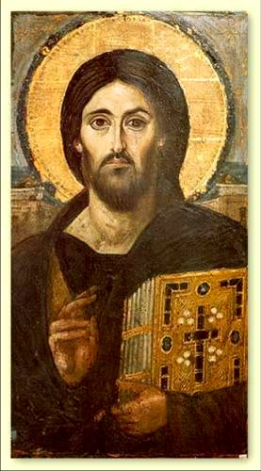

Conversations will vary but will usually include reflection on the objectives set at your last MDR; an opportunity to reflect on your vocation; and a chance to raise any other issues you wish to discuss.

To make the most of the conversation, please reflect on the following questions in advance:

1. *Overview*:

How are things going? What is going well? What is more difficult?

1. *Objectives from your last MDR*:

How are you getting on with the objectives you set at your last MDR?

Have any of the targets been completed – and what has the result been?

Have any of the targets been forgotten – and how might you re-engage with them if so?

Have any of the targets been superseded by other changes – and why?

*If this is your first MDR, please reflect on the following questions:*

What one or two objectives for personal development do I intend to work on over the coming year? *(eg. preaching, handling conflict, developing a discipline of prayer, developing a more wholesome balance of life eg. by building sport into your routine…)*

What one or two objectives for ministerial development do I intend to work on within the coming year? *(eg. offer a Christian Basics Course, develop links with local school, strengthen welcome…)*

1. *Vocation:*

This interim conversation is an opportunity to reflect with a member of the Bishop’s Core Staff Team on your vocation. What reflections do you wish to offer?

As things stand at the moment, where do you see yourself in 3 years’ time?

(eg. continuing in your current post; something else…)

Where do you see yourself in 5–7 years’ time?

1. *Other:*

Are there any other matters you would like to raise?