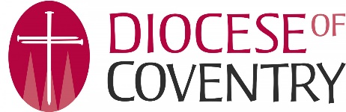
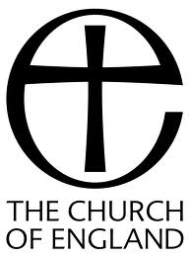
Equal Opportunities Form
Coventry DBF wants to meet the aims and commitments set out in its equality policy. This includes not discriminating under the Equality Act 2010 and building an accurate picture of the make-up of the workforce in encouraging equality and diversity.
The organisation needs your help and co-operation to enable it to do this, but filling in this form is voluntary.
The information you provide will stay confidential and be stored securely and limited to only some staff in the organisation’s Human Resources function.

What is your gender?
Man
Woman
Non-Binary
Other – Please specify
Prefer not to say

Are you married or in a Civil partnership?
Yes
No
Prefer not to say

What is your age bracket?
16-24
25-29
30-34
35-39
40-44
45-49
50-54
55-59
60-64
65+
Prefer not to say

What is your ethnicity?
Ethnic origin is not about nationality, place of birth or citizenship. It is about the group to which you perceive you belong.
White
English
Welsh
Scottish
Northern Irish
Irish
British
Gypsy or Irish Traveller
Other – Please specify
Prefer not to say

Multiple/Mixed Ethnic Groups
White and Black Caribbean
White and Black African
White and Asian
Other – Please specify
Prefer not to say

Asian/ Asian British
Indian
Pakistani
Bangladeshi
Chinese
Other – Please specify
Prefer not to say

Black/ African/ Caribbean/ Black British
African
Caribbean
Other – Please specify
Prefer not to say

Other ethnic group
Arab
Other – Please specify
Prefer not to say

Do you consider yourself to have a disability or health condition?
No
Prefer not to say
Yes – please specify

What is your religion?
No religion or belief
Buddhist
Christian
Hindhu
Jewish
Muslim
Sikh
other – please specify
Prefer not to say

