Conference Details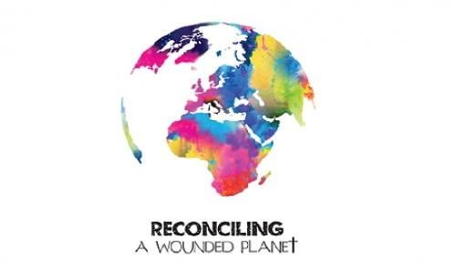
Our message at this conference was one of reconciliation; that ‘God through Christ reconciled the world to himself’.
With environmental issues that affect the stability and integrity of God’s earth, this conference was designed to challenge and equip the church for its mission to carry the gospel hope of Jesus Christ to our communities and God’s world, building on Coventry’s international reputation as a place committed to a ministry of reconciliation.
We invited participants to join us in responding to the gospel message of hope and reconciliation which can transform our congregations, schools and churches to be places that are united in a desire to re-build the broken places of the world.
Our aim was to:
- Understand the gospel challenge of reconciliation in a world where there are conflicting demands on the world’s limited resources, looking both to the future and learning lessons from the past.
- Respond to this crisis by providing a platform for discussion, debate, understanding and resolution, working together to find a way forward for those who seek to understand the nature and extent of the problems and for those who seek to exercise their responsibilities as followers of Christ.
- Equip delegates theologically with a message of good news that will still have impact 40 years on and to inspire young people to become leaders in reconciling people to God’s creation.

The Programme, Events and Activities

Day 1 – Friday 18th September
The conference opened with a welcome to the Cathedral from the Dean of Coventry, The Very Revd John Witcombe, who introduced the Coventry Litany of Reconciliation. The Bishop of Coventry, the Right Revd Dr Christopher Cocksworth, welcomed participants to the conference. This was followed by a short address by Revd Margot Hodson using Colossians 1: 15-20 as her text.

Then Sir Ghillean Prance delivered the keynote speech that reflected on the extent of the current crisis facing our world and his hopes for the lasting impact of this conference.
Delegates then participated in one of a number of discussion streams
- Community Engagement
- Political Engagement
- Health, Education & Well-Being
- Natural Resources
- Enhancing Biodiversity
- Developing Technologies
Within each stream, delegates heard from three speakers who gave brief ‘stories of hope’ and then divided into smaller groups to discuss each of those stories in turn. Within these discussions the groups aim to take forward principles, generating new ideas and vision and preparing to share these in a plenary with the rest of the conference at the end of the day.

Following a buffet dinner, prepared by the new Cathedral Café, Rising from the Rubble, we were delighted to host the Riding Lights Theatre Company who performed their new play, Baked Alaska, based on the environment. This was commissioned by the Diocese of Lichfield with the intention of launching this play at our conference. We were suitably challenged by the performance in the stunning surroundings of the new Cathedral and the play has continued on its progress across the country.

Day 2 – Saturday 19th September
The day began with a theological reflection by Professor Richard Bauckham. This was be followed by small group facilitated discussions responding to issues raised during the conference. Before lunch, Jerry Marshall gave a presentation on the importance of planning, business and finance in implementing change. This was followed by a brief talk by Canon Kenyon Wright on the 40th Anniversary of the first International Community of the Cross of Nails Conference in Sewannee, Tennessee on Ecology and Christian Responsibiity which had been remarkably prescient and which provided an inspiration to this conference.
After lunch, there were opportunities for partnership meetings, enabling participants to meet others with similar topic-based interests and concerns and also with those from their own regions.
This was followed by a final keynote address given by Bishop James Jones, author of ‘Jesus and the World’, in which he summarised the main outcomes of the conference and commissioned us to put into action our own stories of hope for the future.
The conference concluded for most with a short act of worship including the Coventry Litany of Reconciliation; for those who stayed on in Coventry, the 10.30am Eucharist on Sunday 20th September at the Cathedral continued to reflect the themes of the conference with a sermon by the Bishop of Dudley, the Right Revd Graham Usher, a member of the Environmental Working Group of the Church of England.
Café Connect
Throughout the conference, the Cathedral was set up with a specially designed area called Café Connect, open for delegates to relax and network with each other and also where we enjoyed meals in the magnificent surroundings of the new Cathedral building.

Stream Speakers (details as of 2015)
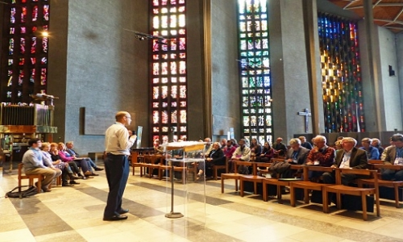
Image: Community engagement stream in action
Stream speakers started each of the six stream meetings with ten minute introductory talks (‘stories of hope’) and they were helped by stream conveners to facilitate the ensuing discussions in which delegates took part actively. Delegates then worked together to produce short summaries for the afternoon plenary session, which was chaired by Professor Sam Berry.

Community Engagement:
Paul Ede (a leader of Clay Community Church, Glasgow and author of Urban Eco-Mission)
Andy Lester (Conservation Director, A Rocha UK)
Joanna Dobson (author of Incredible, the story of Incredible Edible) together with Pam Warhurst CBE, founder of the voluntary gardening initiative, Incredible Edible, in Todmorden
Howard Hutchings (The Rubbish Diet, Shrewsbury), together with Alison Thomas (The Rubbish Diet) who will be also disposing of our biodegradable plates, cutlery etc and our recyclable beakers in an eco-friendly way
Convener: Andy Lester

Political Engagement:
Ian Christie (Fellow, Centre for Environmental Strategy, University of Surrey)
Ben Niblett (Campaigns Team Leader, Tearfund)
Richard Gower (Director of Foresight Economics, a consultancy engaged with Tearfund's Horizon Project and now on the staff of Tearfund)
Convener: Dr Samuel Ewell, Community and Formation Minister, Newbigin Centre, Birmingham and Theological Advisory Panel, RaWP
(in attendance, Michael Northcott (Professor of Ethics, University of Edinburgh and author of A Moral Climate))
Sadly , Mike Hulme had to drop out as he had an unexpected new work commitment that he had to fulfil: we are very grateful to him for his work on the Advisory Panel which has been absolutely invaluable and he gave real direction to the conference)

Health, Education and Well-Being:
James Hindson (Founder and Director of Sense and Sustainability)
Ruth Valerio (Churches and Theology director, A Rocha)
Martin Hodson (John Ray Initiative, Co-Director and Principal Tutor for Christian Rural and Environmental Studies (Ripon College, Cuddesdon) and Visiting Researcher in Environmental Biology, Oxford Brookes University)
Convener: Sam Slatcher, Member of the Advisory Panel, former Reconciliation intern and current PhD student at Durham University and Emma Griffiths, Associate Director for Reconciliation and Head of Education Department, Coventry Cathedral

Natural Resources:
Caroline Pomeroy (CEO of Climate Stewards)
Rob Havard (Freelance ecologist and Managing Director at Rob Havard Associates, Phepson Farm)
George Browning (Feldon Forest Farm: organic farming)
Convener: Bishop Graham Usher, Bishop of Dudley, a member of the Environmental Working Group of the CofE and of the Theological Advisory Panel, RaWP

Developing Technologies:
Mike Clifford (Associate Professor, Faculty of Engineering, Nottingham University)
Ant Wilson (Director, AECOM Sustainability and Building Engineering)
Drew Purves (Microsoft Systems and Treasurer of the British Ecological Society)
Convener: Revd Chris Halliwell, Blackburn Diocesan Rural and Environmental Project Officer and Co-Vice Chair of Operation Noah

Enhancing Biodiversity:
Mike Morecroft (Senior Visiting Research Associate at Oxford University in Ecology, Climate Change ecologist at Natural England)
Bob Sluka (Lead Scientist, Marine and Coastal Conservation Programme, A Rocha International)
Brian Cuthbertson (Head of Environment and Sustainability, Diocese of London)
Convener: Peter Brotherton, (Head of Biodiversity, Natural England)

Mini-plenary on Saturday morning on the importance of planning, business and finance in implementing change: Jerry Marshall (Founder Chairman of Transcend Support Ltd and CEO of the Arthur Rank Centre encouraging rural economies through the Germinate Enterprise initiative)

Conference Plus
During the evening of Thursday 17th September Coventry Cathedral hosted a screening of the film ‘Scarred Lands and Wounded Lives’. This evocative film depicts war’s impact on the environment and you can view it on-line as a short YouTube trailer or at http://www.scarredlandsfilm.com/. It projects a very powerful message and bears watching more than once. As one commentator, Charles, writes, ‘Should be seen by everyone on the PLANET....’
We were very pleased and honoured to welcome the film makers, Alice and Lincoln Day from Washington DC to this event and were delighted that they stayed with us for the rest of the conference. They screened new footage on 27th March 2015 in Washington DC at the Environmental Film Festival in the Nation's Capital

Following the film, a Panel consisting of Rev Professor Philip McCormack, MBE (the Army's academic lead on ethics and Deputy Principal of the Armed Forces Chaplaincy College), Canon Dr Sarah Hills (Canon for Reconciliation at Coventry Cathedral), Dr Alan Storkey (author of Jesus and Politics: Confronting the Powers) and Dr Hilary Marlow (Course Director of the Faraday Institute for Science and Religion and an Affiliated Lecturer in the Faculty of Divinity, University of Cambridge), chaired by the Bishop of Coventry, discussed issues raised by the film with the audience.

