

**President of Readers : The Lord Bishop of Coventry**

Bishop Christopher is pleased to announce the appointment of Fiona Trewick as Assistant Warden of Readers to work alongside Jo King, Warden of Readers.

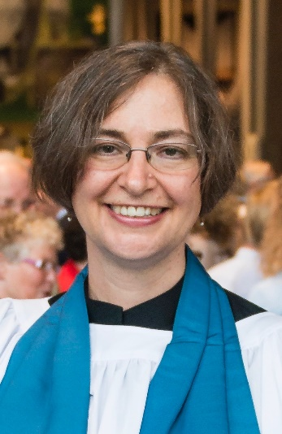

Fiona has been working as part of the Reader Team for a number of years, bringing a passion for learning and for developing the skills and knowledge of Readers in different areas. She has demonstrated her gifts in leading the Reader Development Group, and supporting the training of new Readers and the wider Reader Leadership Team. Jo is delighted to welcome Fiona to work alongside her and, in this season of change, is pleased to have someone with Fiona’s breadth of experience of Reader ministry in this key role. Fiona’s vision is that Reader ministry should flourish and develop within the newly created Lay Ministries Framework and looks forward to all that lies ahead.