

Nomination to House of Clergy of Diocesan Synod

Diocese of Coventry
Deanery of Alcester

Election of members of the House of Clergy of the Diocesan Synod.

We the proposer and seconder, each being qualified electors and members of the House of Clergy of the Deanery Synod for the above Deanery, nominate the following person as a candidate at the election in the above Deanery.

Surname | Christian Names | Postal Address | Email Address | Year of Birth

Proposer’s signature……………………………………………………………………………………………………………
Proposer’s full name……………………………………………………………………………………………………………
Address……………………………………………………………………………………………………………………………….
……………………………………………………………………………………………………………………………………………

Seconder’s signature…………………………………………………………………………………………………………..
Seconder’s full name…………………………………………………………………………………………………………..
Address……………………………………………………………………………………………………………………………….
…………………………………………………………………………………………………………………………………………….

I, the above named ……………………………………………………… declare that I am not subject to any disqualification referred to in the Notes on this form and signify my willingness to serve as a member of the House of Clergy of the Diocesan Synod if elected.

Candidate’s signature………………………………………………………………………………………………………….

This nomination must be sent to the Presiding Officer, Ruth Marlow (Diocesan Secretary) no later than noon on Wednesday 23 June 2021.

Forms can be returned via email to elections@coventry.anglican.org
Or via post to:
Presiding Officer
Cathedral and Diocesan Offices
1 Hill Top
Coventry
CV1 5AB

Notes
- All members, other than co-opted members of the House of Laity of the deanery synod are qualified electors.
- (1) A person is disqualified from being nominated for membership of a diocesan synod if the person is included in a barred list (within the meaning of the Safeguarding Vulnerable Groups Act 2006).
(2) A person is disqualified from being nominated for membership of any Synod if the person has been convicted of an offence mentioned in Schedule 1 to the Children and Young Persons Act 1933 (with that expression being construed in accordance with Rule 71(2) of the Church Representation Rules).
(3) A person’s disqualification under sub-paragraph (2) may be waived by the bishop of the diocese by giving the person notice in writing.

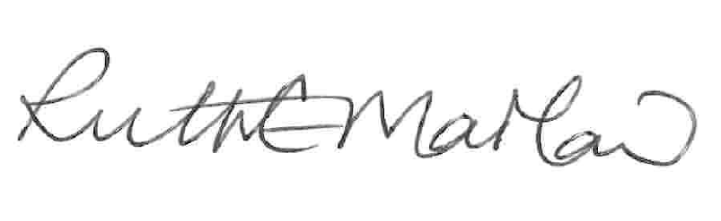

Ruth Marlow Date: 1 June 2021
Presiding Officer

