A LITURGY FOR ADVENT

CALL TO WORSHIP
Among us the Spirit of God conceives new life,
and we feel the life within us.

In our history the Christ makes gentle entry,
and we see the light before us.

Within our dreams the truth of our God is revealed;
we await the hope of the world.

Mary of Nazareth,
flowing bravely
with all the possibilities
for life,
touching close the deep centres
of being,
and present to the Holy Spirit
of God,
creating and moving
and bursting through
membranes of pain and doubt,
through labour-filled passages
into the light
of the star-shine world
and the poor,
who kneel in hope
before the sign of God.

O God, give to us all the eyes and heart of Mary,
who saw the vision for the liberation of the world,
and with love and courage committed herself
to live out that hope.
Amen.

CONFESSION
In silence,
let us reflect on moments in our own lives and in the life of the Church
when we have experienced
the life-giving movement of the Holy Spirit
and have allowed it to die –
moments when we have had
a sense of grief about ourselves,
a sense of betraying our own possibilities.

In weakness,
in smallness of hope,
in vulnerable faith,
we stand before you, O God.
We come in penitence
and await your renewing Spirit.

ASSURANCE OF PARDON
Where the Spirit of the Lord is,
there is liberty!
God is always faithful to us
and gives to us a new day.
Amen. Amen!

Silent reflection

AFFIRMATION OF FAITH
Let us affirm our faith:

We believe in God
who lives and speaks in sunsets,
in love-wrapped gifts,
and fleeting butterflies’
in women weeping strongly
for stillborn dreams
and hopes they never conceived.
We believe in God,
indwelling wholly,
in suffering and celebration.

We believe in Christ,
honouring our humanness,
who took nourishment
from a woman’s breasts;
who climbed trees,
skinned knees;
who laughed and cried,
loved and wept,
bled and died.
We believe in the Christ, sanctifying life, and death.

We believe in the Spirit,
mystically joining us
to peoples everywhere;
who intercedes
with sighs and groans
too deep for words;
a share consuming struggle
bending our will to God.
We believe in the Holy Spirit
incorporating us into Christ.

We believe in the Church,
being and becoming,
chosen as God’s presence in the world
despite its frailty,
its foolishness,
its failings.
We believe in the Church,
seeking, however imperfectly,
to act justly, love mercy,
and walk humbly with our God.

DEDICATION
As Mary offered herself in her humanness, so we offer our gifts to you, O God.
We bring them in faith.
We bring them in gratitude
for all that we have received.
Amen.

BLESSING AND DISMISSAL
Rejoice in Bethlehem,
two thousand years ago.
Rejoice in the life
that was conceived,
lived and given for us.

Go in peace
to love and serve the world.
And may your waiting be in hope,
each day be lived in faith
and the love in Christmas be moving toward you.
Amen

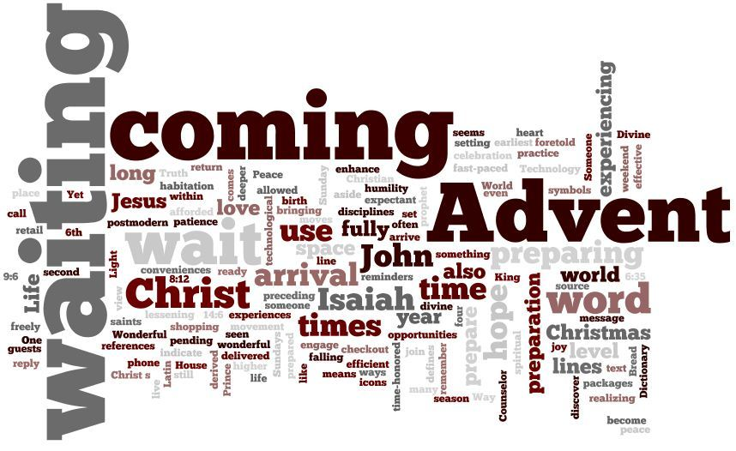
AN ADVENT LITURGY

