13. MDR Interim Conversation (Jonah)
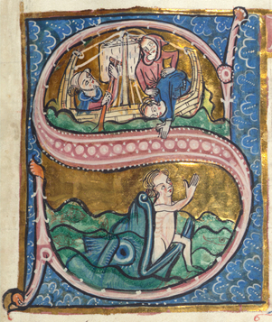

Conversations will vary but will usually include reflection on how things are going; a review of the objectives you set in your personal development plan; an opportunity to reflect on your vocation; and a chance to raise any other issues you wish to discuss.

To make the most of the conversation, please reflect on the following questions in advance:

- Overview:
How are things going? What is going well? What is more difficult?

- Personal Development Plan:
How are you getting on with the objectives you set in your personal development plan

- for personal development?
- for ministry development?
- to take courses in safeguarding?

Have any of the objectives been completed – and what has the result been?

Have any of the objectives been forgotten – and how might you re-engage with them if so?

Have any of the objectives been superseded by other changes – and why?

- Vocation:
At your MDR you were invited to reflect on God’s call, and on the extent to which you were able to focus on that call. Are there any reflections you wish to offer at this stage?

As things stand at the moment, where do you see yourself in 3 years’ time?
(eg. continuing in your current post; something else…)

Where do you see yourself in 5–7 years’ time?

- Other:
Are there any other matters you would like to raise?

