4. MDR Preparation Questions for those in parish ministry – The Four Living Creatures
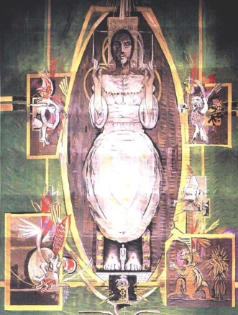
As you prepare for your MDR, you are invited to read Revelation 4:6b-11. The questions that follow draw on the imagery of the four living creatures, which are in turn represented in Graham Sutherland’s great tapestry in our Cathedral.
We read in the passage that the four living creatures worship God ceaselessly, and in response to their worship, the twenty-four elders fall down and worship the one seated on the throne. The living creatures are, in a way, enabling the elders’ worship – just as those of us involved in ministry may find ourselves, however imperfectly and incompletely, enabling other people to worship.

Each of the themes below draws on traditional attributes associated with each creature: the image of one like a lion is one of strength; the image of one like an ox is of a beast of burden; the image of one like a human being is one of humanity; the image of one like an eagle is one of flight and perspective. So in turn the questions invite you to go deeper into these themes and reflect respectively on your God-given strengths and gifts; on the tasks before you in your current ministerial context; on yourself and your own wellbeing; and on what would enable you to soar in your ministry. None of the creatures exists in isolation, however, and they all have their part to play in the heavenly worship; so in turn the questions are designed to help you reflect on the whole of your life and ministry, recognising that particular joys or challenges in one area may well impact upon everything else.
This template is intended as a starting point for your reflections and for your discussion with your MDR reviewer, and if there are other matters that you wish to raise as part of your review, please indicate this at the end. This form will remain confidential between you and your MDR reviewer.

Questions for Reflection and Discussion
Please continue on additional pages as necessary.

Living creature like a lion
- What has gone well in the past year? What do you want to celebrate?

- What are your particular gifts, strengths and interests?
To answer this question, in addition to your own self-knowledge, you may want to draw on the external feedback you have received for this MDR. There are other resources available to help you to assess your strengths if that might be helpful eg. Strengthsfinder 2.0.

- Are you able to use your gifts, strengths and interests in your current ministry?

Living creature like an ox
- What is the vision for your ministerial context?
To answer this question, you may want to draw on eg. your Role Description, feedback from a recent 8EQs survey, parish vision statement etc.

- What are the external challenges or obstacles ?

- What would you or others identify as your current areas of weaknesses?
In addition to drawing on your own self-understanding, you are invited to reflect on the answers given to question 2 on the MDR Feedback Form for Nominated People.

Living creature like a human being
- How are you? How are you finding ministry?

- How would you characterise your relationships at present
- within your ministerial context?

- with friends and family?

- Recognising that peaks and troughs are part of every Christian journey, how would you characterise your spiritual life at present?

Living creature like an eagle
- What would enable you to soar in your ministry?

- Given your context and responsibilities, what personal development would be helpful, or what skills or knowledge do you need to acquire?

- As things stand at the moment, where do you see yourself
- in 3 years’ time?

- in 5–7 years’ time?

If there are other matters you wish to raise at your MDR, please indicate this here:

