5. MDR Alternative Preparation Questions for those in parish ministry – Jonah

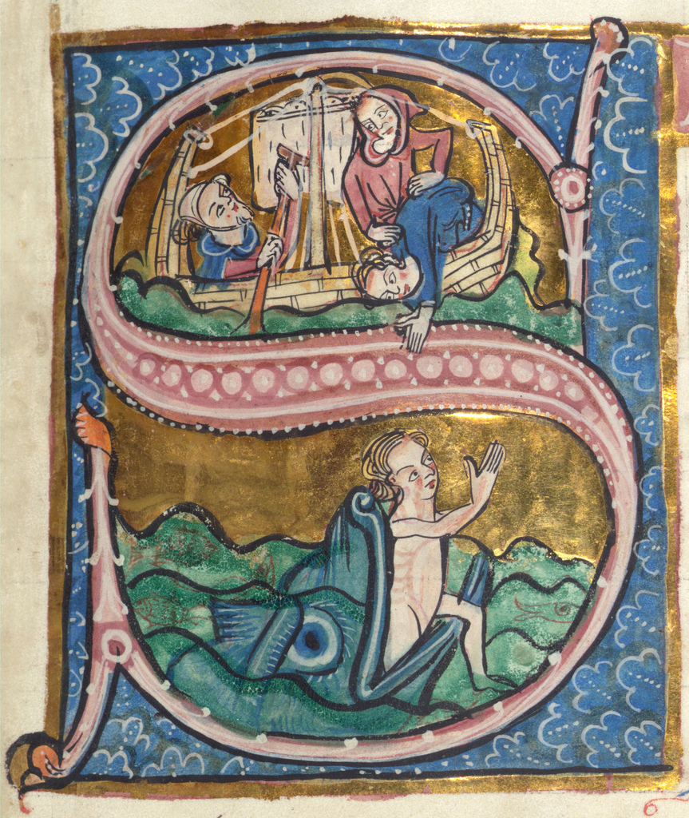
As you prepare for your MDR, you are invited to read the book of Jonah. Within four short chapters we read of God’s call to the reluctant prophet; of storm; of unexpected rescue and respite; and of the varied responses of the human participants to God’s activity. We encounter both reluctance and self-sacrifice; fear and thanksgiving; anger and mercy; prophecy and conversion. Particular themes may resonate with elements of your ministry, and as you read, you are invited to reflect on your own vocation in all its joys, storms, and wonders.
This template is intended as a starting point for your reflections and for your discussion with your MDR reviewer, and if there are other matters that you wish to raise as part of your review, please indicate this at the end. This form will remain confidential between you and your MDR reviewer.

Questions for Reflection and Discussion
Please continue on additional pages as necessary.

- What is the call?
To answer this question, you may want to draw on e.g. your Role Description, feedback from a recent 8EQs survey, parish vision statement etc.

- How able are you to focus on following that call at present? If a significant proportion of your time is spent in other ways, do you have a sense of why that might be?

- For what do you want to give thanks? What has been rewarding about ministry over the past year?

- What are the storms or obstacles?

- What would you or others identify as your current areas of weaknesses?
In addition to drawing on your own self-understanding, you are invited to reflect on the answers given to question 2 on the MDR Feedback Form for Nominated People.

- Given your context and responsibilities, what personal development would be helpful, or what skills or knowledge do you need to acquire?

- Is there anything you need to let go of over the coming year?

- Who supports you in your ministry – and in your current ministerial context?
E.g. family, friends, spiritual director, cell group, deanery chapter…

- Are you content with the balance of your life at present?

- Recognising that God’s call can at times lead us into some unwelcome or unsettling places, how would you characterise your spiritual life at present?

- What has excited or interested you theologically over the past year?

- Reflecting on God’s call, as things stand at the moment, where do you see yourself in
- 3 years’ time?

- 5–7 years’ time?

If there are other matters you wish to raise at your MDR, please indicate this here:

